CHESTER ANGLICAN
CURSILLO®
NEWSLETTER
Spring 2018

Vicki Schofield is currently on sabbatical so there is no SD report. We pray that she will return refreshed both physically & spiritually.

In each newsletter we’re going to interview a member of the secretariat so that you get to know them better, here’s our first interview.
Getting to know……Mary Mitchell.

You are the Lay Director for Chester Cursillo, what does that role involve?
It is a privileged role , to try and keep an overview of Chester Cursillo and try and keep in line with BACC guidelines. Chairing Secretariat meetings, listening and supporting the officers elected in their various roles. Leading Diocesan Ultreyas , being available as much as possible to attend Clauseras, and staff training days. Attending BACC meetings twice a year. Generally trying to keep on top of things happening in and around Chester Cursillo Diocese.

Can you explain what the role of secretariat is?
The Secretariat is the name given to the Diocesan body which has the responsibility for the life and direction of the Cursillo movement in a Diocese.
The Secretariat can be described as a group of leaders, clergy and lay people appointed for the purpose of encouraging , guiding and serving the Cursillo movement so that it may be an efficient movement. We meet regularly and also with the lay rectors from the servant community . the agenda items are reports from the officers and any other business that has arisen. We support and encourage each other. The officers on the Secretariat are Lay Director, Spiritual Director, Secretary, Treasurer, BACC representative, Palanca secretary, Fourth Day Officer, Weekend coordinator, Communications officer. We hold office for 3 years and can serve up to another 2 years as per our constitution.

Is this the first role you’ve had on the secretariat?
No this isn’t my 1st role on the Secretariat, I was secretary for a few years before.

What was the highlight/outstanding memory of your Cursillo weekend?
All of it! But if I had to choose a moment it would be the festival of light.

What impact did the weekend have on you?/What changes occurred in you after your weekend?
When I attended Church after my weekend a friend said “you’ve changed”. The way God worked in me over that weekend made me more confident in my faith , and more open to allowing God to lead me in things I didn’t think I could do.

When you’re not being Lay director, what’s your day job?
I work in the radiotherapy department at Christie Hospital. I used to deliver the radiotherapy treatment to the patients, but my role has changed now, I am involved with the immobilisation of the patients to help them stay in the same position for their treatment. This is a very rewarding job and I love being ‘there’ for the patients.

What’s your favourite way to spend a day off?
With the Grandchildren, I have four, aged 18months, 4 years old, 5 years old and 8 years old.
The cleaning and washing –up will still be there the next day, the time with the Grandchildren is precious.

Thank you Mary, next time …..

HERE’S A GIFT WHICH GROWS WITH YOU
This Gift can:
Open your mind to the mind of Christ
Give you time and space for reflection
Encourage you to listen and find where God moves in your life
Encourage your friends
Encourage you to transform inwardly.
...............................................................................................................................
PEEP INSIDE...and you will see:
Friends inviting the Holy Spirit in
Friends encouraging you in silence
Friends giving you this rare gift of time and space
Friends encouraging you to listen and find where God is moving in your life.
RECOGNISE IT? IT’S GROUP REUNION OF COURSE. That’s a special gift indeed. Maybe your Group Reunion is looking a little misshapen? Does it seem like a chat time; helping people through their problems? How about agreeing to save any discussion until after those closing words, “We give you thanks, Almighty God, for all the benefits you have given us...” and naturally only if the person with the problem asks us to! After all Group Reunion is the rare benefit of encouragement to look INWARD at your outward Christian living, different from those other great benefits of corporate worship, housegroups or study groups.
Key features of Group Reunion are:
it’s short
it’s about listening
it’s about receiving rather than discussing
it’s about sharing
it’s encouraging.
In fact IT’S A GIFT!
Romans 1 v 11-12
St Paul said,” I am longing to see you so that I may share with you some spiritual gift to strengthen you-or rather that we may be mutually encouraged by each other’s faith, both yours and mine”.
Sue Hutt

National Ultreya 2018
ULTREYA GB 2018 will be hosted by Chelmsford diocese on 1st September 2018 and details of the event can be found by clicking on the link below.
http://www.chelmsfordcursillo.com/ultreya_18.html

National Ultreya 2019.
We are hosting the National Ultreya next year 31st August 2019. This is a gathering of Cursillistas from all over the U.K. and is held annually. It is a wonderful uplifting event. It consists of an Ultreya with witness talk, biblical reflection, and floating group reunion, lots of singing, and a Eucharist presided usually by the Bishop in the Cathedral of the hosting Diocese.
We have booked Chester Cathedral and the Bishop and are holding the whole day’s event in the Cathedral. A small group of us are at the beginnings of arrangements and sorting practicalities, but as the date gets closer I would love you to keep in mind that we will need lots of help and volunteers for various roles nearer the time, and on the day. I ask also that you hold the event in Prayer, that we do Chester Cursillo proud and help other Cursillistas from all over the U.K. to come and have a wonderful day.

Chester Cursillo Recipe Book
To raise funds for Chester Diocesan Cursillo (as we are hosting the 2019 National Ultreya) I am collating recipes for a “Bring and Share” Recipe Book.
The intention is that it will provide all the tasty recipes we enjoy when we are sharing fellowship together. I intend getting offerings from as many Cursillo Dioceses as possible but hope Chester Diocese is particularly well represented as it will be our book. So please email me your tried and tested favourites. Hot, cold, sweet, savoury - anything that goes down well when we meet together.
Please include your name and diocese so that they can be attributed. ejrbeth@btinternet.com

Beth

Day of Deeper Understanding
A DDU or Day of Deper Understanding is an opportunity to spend a day exploring Cursillo in Chester Diocese. Looking at how it works for the diocese but also for you as an individual, are we getting the best out of the tools it offers?
Chester Cursillo will be running a DDU at the end of the year, date to be confirmed, hopefully at Foxhill.
A small team will put together the talks, music and worship, if you’d like to be involved please contact our Lay director Mary Mitchell.

Easy Fundraising – A guide to getting started
££££££££££££££££

This is a simple to use process. You buy online in the same way that you always do. The only difference is, you access the website you want to buy from, by going ‘through’ the Easyfundraising website.

Say for example, you want to buy something from Amazon. Rather than going straight to the Amazon website, you go to the Easyfundraising website and then follow the link to the Amazon website. It’s that simple.

Easyfundraising doesn’t hold any of your details, so it’s safe and secure.

Setting up an account is easy.

- Go to the website: easyfundraising.org.uk
- Search for Chester Cursillo
- Click the ‘Join us’ icon
- Enter your name, email and password
- If you don’t want any promotional emails, ‘Uncheck’ the ‘Please send me helpful hints etc box
- Click on ‘Create an account’
- Select ‘Yes’ or ‘No’ for Gift Aid
- Click ‘No thanks’ if you don’t want the donation reminder.
- Click on ‘Get started’, and you’re away – Ultreya!!

Next time you want to buy something, it’s EASYFUNDRAISING first.
- Simply go to the website: easyfundraising.org.uk
- Select a retailer
- ‘Go shopping and raise funds.

Its as simple as that-Happy shopping!

££££££££££££££££

In order to comply with the new General Data Protection Regulations, we have had to email everyone on our database to ask permission to hold their data. We have now updated our records, so you should only be receiving this if you replied to us. Hopefully it will mean we have a better idea of who is active within Chester Cursillo.

In last years spring Newsletter there was an article about sponsorship, we thought it would be helpful if you could see what was in the letter & form you would receive from the Weekend Co-ordinator if you decided to sponsor someone and therefore what you are agreeing to do.
Dear
has applied to be a participant on the Cursillo weekend at ………..this year and has given your name as Sponsor.
Sponsorship primarily involves
- supporting the participant in prayer before and during the weekend
and any or all of the following elements:
- attending Wake Up, Sunday, 27th May at Wistaston Hall
- attending the Clausura, Sunday 27th May at 3.30pm at All Saints Church, Crewe
- inviting any other supporters to join the Clausura, whether or not they are cursillistas, perhaps the participant’s spouse or close friend.
- keeping some contact after the weekend to encourage him/her to meet in Group Reunion (which will be arranged by his/her local Ultreya Lay Rector.
- encourage the participant to speak to their parish priest about attendance
Please contact me to let me know whether or not you are able to accept this invitation to sponsor this participant. I am enclosing a Sponsor Form for you to complete and return to me. If you have difficulty with any of the above responsibilities or would like to share the responsibility with any other Cursillista known to the participant then please contact me as soon as possible so that alternative arrangements can be made.
Please contact me if you need any other details.
Yours in Christ

Chester Cursillo - Sponsors Form

Sponsor’s name .................................................................................
Participant’s name .................................................................................
I will hold this Participant in prayer each day.
I will be in touch with this Participant before the weekend. Yes/No
I will explain the busy schedule of the weekend and the expectation of participation (generally from 7 a.m. to 10 p.m. each day). Yes/No
I will offer this Participant transport to and from the weekend. Yes/No
If “No”. I understand this Participant has transport arranged as follows:-
..........................................................................................................................
I will be delighted to come to Wake Up. Yes/No
If “No”, or you are on the staff team:
I have arranged for ........................................ to come instead as Co-Sponsor.
I will look forward to being at Clausura. Yes/No
If “No”, or you are on the staff team:
I have arranged for ....................................... to come instead as Co-Sponsor.
I will contact this Participant soon after the weekend and encourage their participation in Fourth Day Community Activities.
The participant’s parish priest is aware of their attendance on the weekend Yes/No
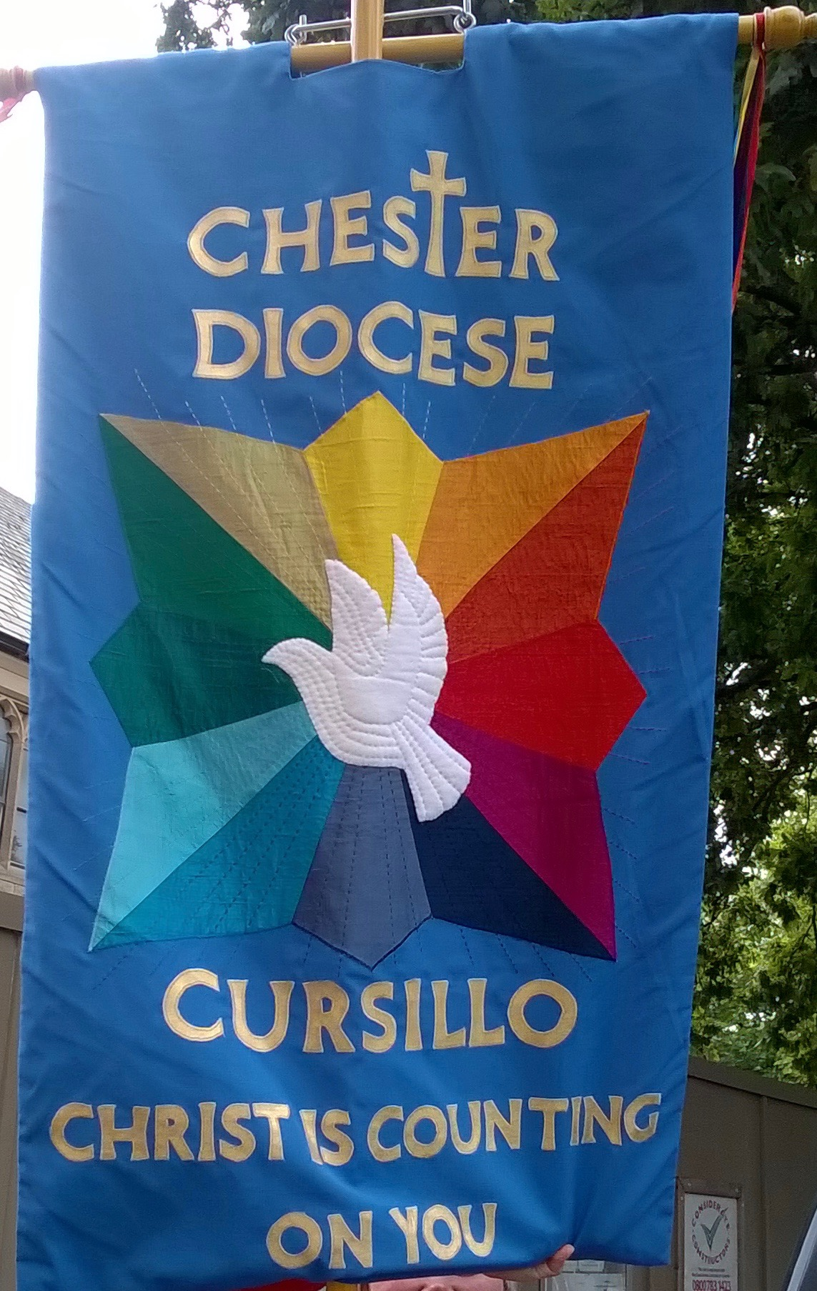
Banner Blog

I was allowed to attend the Mothers Union Deanery festival in March. This was an unexpected but wonderful thing to do. I was there because the lady who designed and made me had also made and designed the Mothers Union Deanery banner and St Matthews Mothers Union banner. She was going to the service so we all stood together and I was immensely proud of the occasion.
Weekend #55 went really well and the participants had a wonderful time (as did the staff!) under the guidance of Lew and his great team. As always I love being part of these weekends.
I have one bone to pick though, Mary forgot to take me to the Diocesan Ultreya at St Mary’s Church in Nantwich! I was so looking forward to it as well.
Mary has said that the National Ultreya is in Chelmsford this year on the 1st September, so looking forward to representing us there and meeting up with my other banner friends from around the UK . Again as last year I will check out what happens ready for 31st August 2019 when we are hosting the National Ultreya in Chester.

Lay Director  laydirector@chestercursillo.org.uk | Mary Mitchell
Spiritual Director  spiritualdirector@chestercursillo.org.uk | Vicki Schofiled
Hon Secretary  secretary@chestercursillo.org.uk | Anne Smith
Hon Treasurer  secretary@chestercursillo.org.uk | Nick Hutt
Weekend Co-ordinator  weekend@chestercursillo.org.uk | Pam Ross
Fourth Day Officer  fourthday@chestercursillo.org.uk | Sue Joy
Palanca Secretary  palanca@chestercursillo.org.uk | Sue Lewis
BACC Rep  baccrep@chestercursillo.org.uk | Sue Hutt
Communications officers  communications@chestercursillo.org.uk | Carol Thayer &  Anne Vetter

